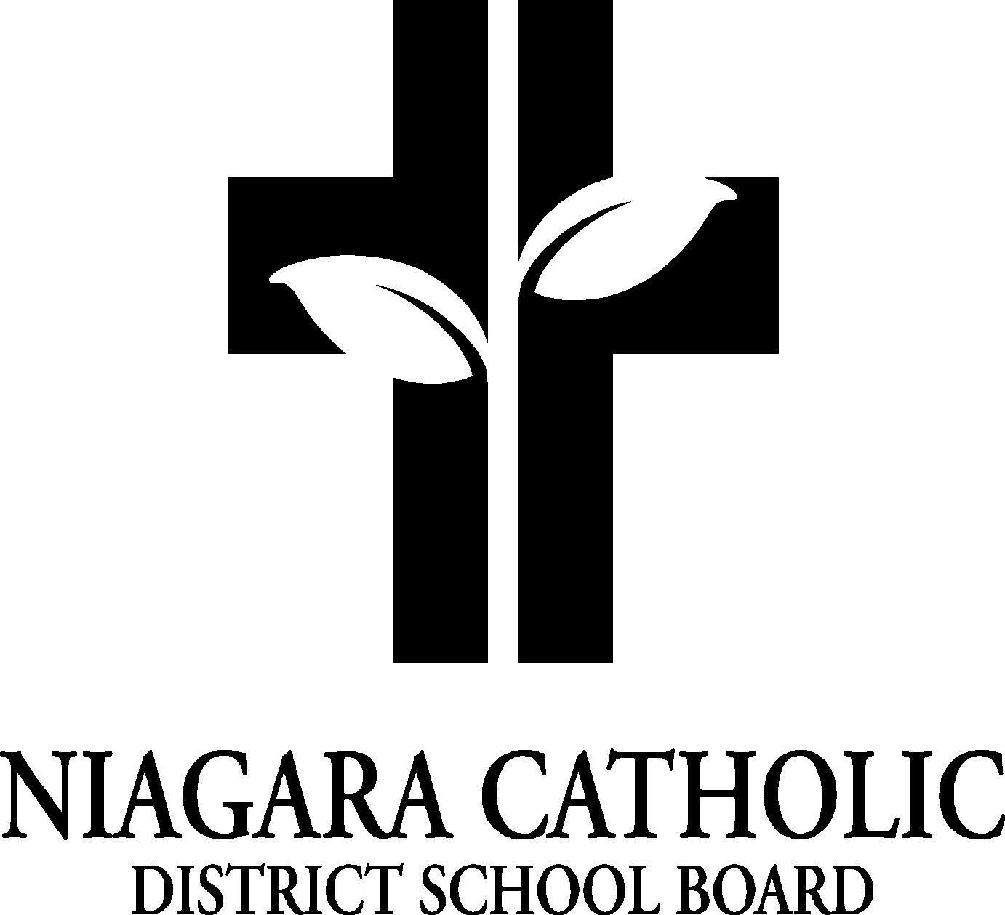
St. Patrick Catholic School Council November 10, 2022

A. ROUTINE MATTERS

- Opening Prayer - MK
- Presentation – Fundraising presentations
3. Roll Call

Members | Affiliations | Present | Excused | Absent
 | Chair – Mrs Maloney |  |  | x
 | Co-Chair – Mrs. Maltman | 
 | Secretary/Treasurer-Principal
 | Recording Secretary – Principal | 
 | Teacher Representative – Carrie Gillespie |  |  | X
 | Non-Teaching Representative – Ralph Caperchione | 
 | Parish Representative – Father Wes |  |  | V
Parent Representatives and email address
 | Mrs. Honsberger | 
 | Mrs. Eckert | 
 | Mrs. Loeffen | 

5. Approval of the Agenda

Moved by the committee
THAT the St. Patrick Catholic School Council approve the Agenda of the St. Patrick Catholic School Council Meeting on Thursday November 010, 2022
CARRIED

6. Disclosure of Interest - NONE


AGENDA

7. PRESENTATIONS- None

8. PRINCIPAL’S REPORT
- Fundraising ideas – The council was sent via email some fundraising ideas.
Fundraiser #1: It was decided that we would collect gift cards from our families in our school during November and December and put together a prize February calender to be sold in January. Mrs. Kalagian will prepare a letter to go home next week.
Fundraiser #2: We will sell Big Box cards right after March break through easter.
Fundraiser #3: Trivia Night will be done in the spring to help offset the cost of Camp Medeba for our Grade 7 and 8 students. Ralph Caperchione agreed to run the Trivia Night for us.
- Mrs. Kalagian shared with the council that the Grade 7 and 8 trip to Camp Medeba was approved that morning by the superintendent. Five schools will be going together: St. Elizabeth, St. Patrick, St. Therese, St. Joseph and Our Lady of Victory.
- We will be having a Christmas Concert in December. More information will follow.

9. NEW BUSINESS/QUESTION
10. NEXT MEETING: Thursday January 19, 2023 at 6:00 pm unless we need one before that.

11. ADJOURNMENT Mary Kay Kalagian Moved by Ralph Caperchione Seconded by ______Ralph aT the November 10th meeting of the St. Patrick Catholic School Council be adjourned.
This meeting was adjourned at 6:40 pm
12. CLOSING PRAYER: Mary Kay Kalagian

